Descriptive

Descriptive Statistics
 | N | Minimum | Maximum | Mean | Std. Deviation
Date | 11 | . | . | . | 00:00:03.317
trade_balance | 11 | 957,0 | 6.340,0 | 4.537,727 | 1.759,9075
inflation | 11 | 13.0 | 163.3 | 45.900 | 41.5807
exports | 11 | 3.093 | 11.404 | 5.11645 | 2.867037
imports | 11 | 7.850 | 10.044 | 9.23345 | .659265
balance_deficit | 11 | -957,000 | 6.340,000 | 4.240,40036 | 2.405,941231
Valid N (listwise) | 11

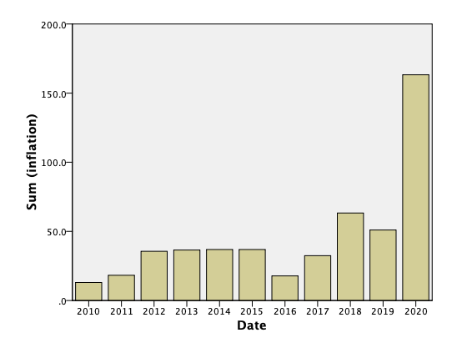

Graph
